18650/TP4056 1A 3.7-4.2V Lipo Battery Charging Board Micro USB with current protection
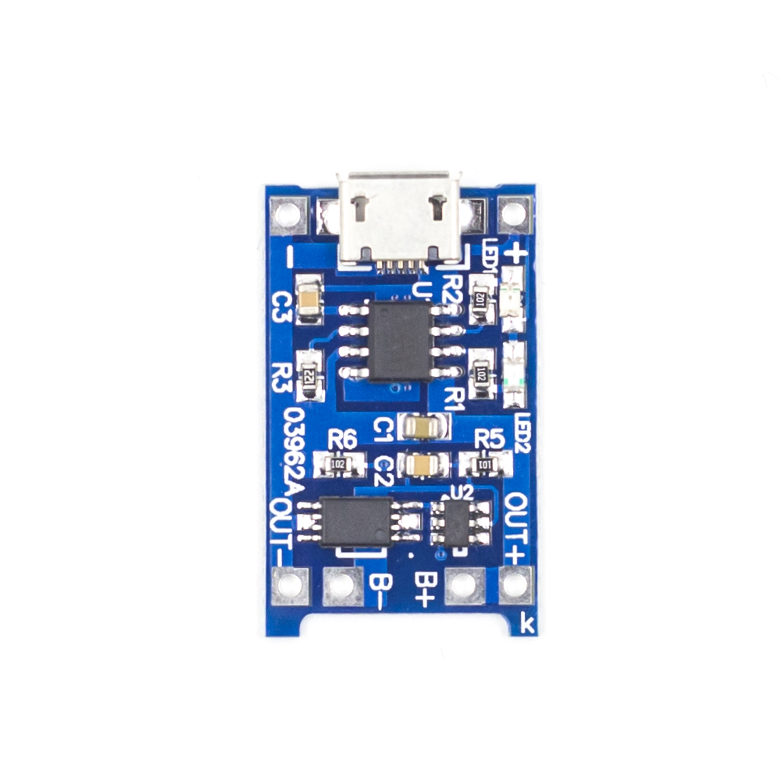
Product introduction
1. Input voltage: DC 5V;
2. Charging cut-off voltage: 4.2V ±1%;
3. Maximum charging current: 1000mA;
4. Battery over-discharge protection voltage: 2.5V;
5. Battery overcurrent protection current: 3A;
6.Input with MICRO USB female socket, you can directly use the cell phone charger as the input power to the lithium battery charging;
7.It can be used for charging and discharging protection of 18650, polymer and other lithium batteries with voltage of 3.6V 3.7V, single or multiple batteries in parallel can also be used.

Usage
1.MICRO USB female socket and the + - pad next to it is the power input, B+ connects to the positive terminal of the lithium battery, B- connects to the negative terminal of the lithium battery.OUT+ and OUT- connect to the load, you can connect to the positive and negative terminals of the mobile booster board or other loads.
2. Connect the battery to B+ B-, insert the cell phone charging cable to the USB female socket, the red light is on for charging, the blue light is on for full.

Note
1. When connecting the battery for the first time, there may be no voltage output between OUT+ and OUT-, then the protection circuit can be activated by charging the module with DC 5V voltage, and the battery needs to be charged to activate the protection circuit if it is disconnected from B+ B- and connected again. When using a cell phone charger as the input power supply, note that the charger and charging cable must be able to support 1A current output, otherwise the module may not be able to charge the battery properly;
2. When charging the battery should be disconnected from the OUT end of the load, positive and negative poles can not be connected to the wrong, please use in accordance with the norms, otherwise it will damage the module.

Functional Diagram
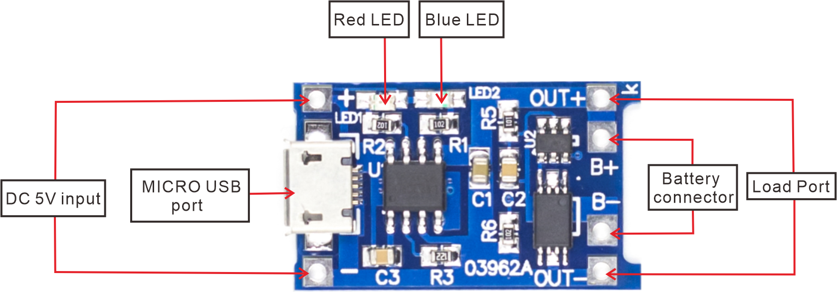
Charge the battery
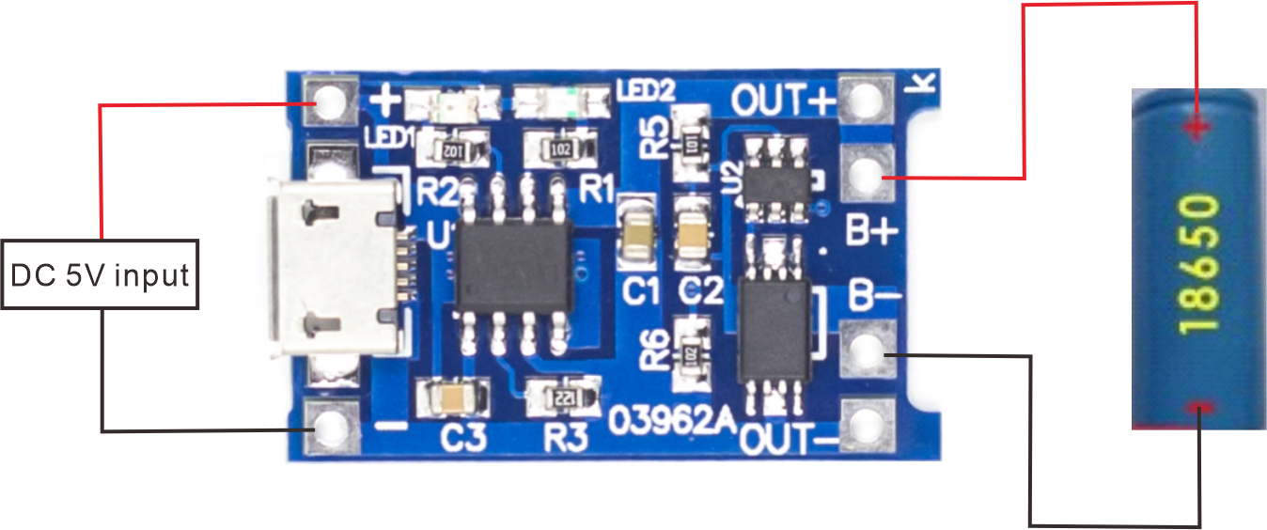
Batteries powering loads
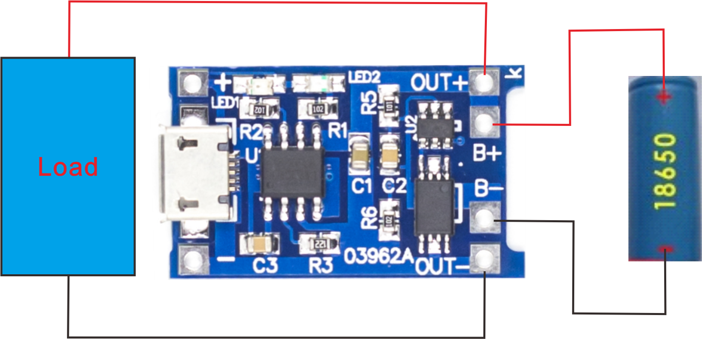

Dimensional drawings

